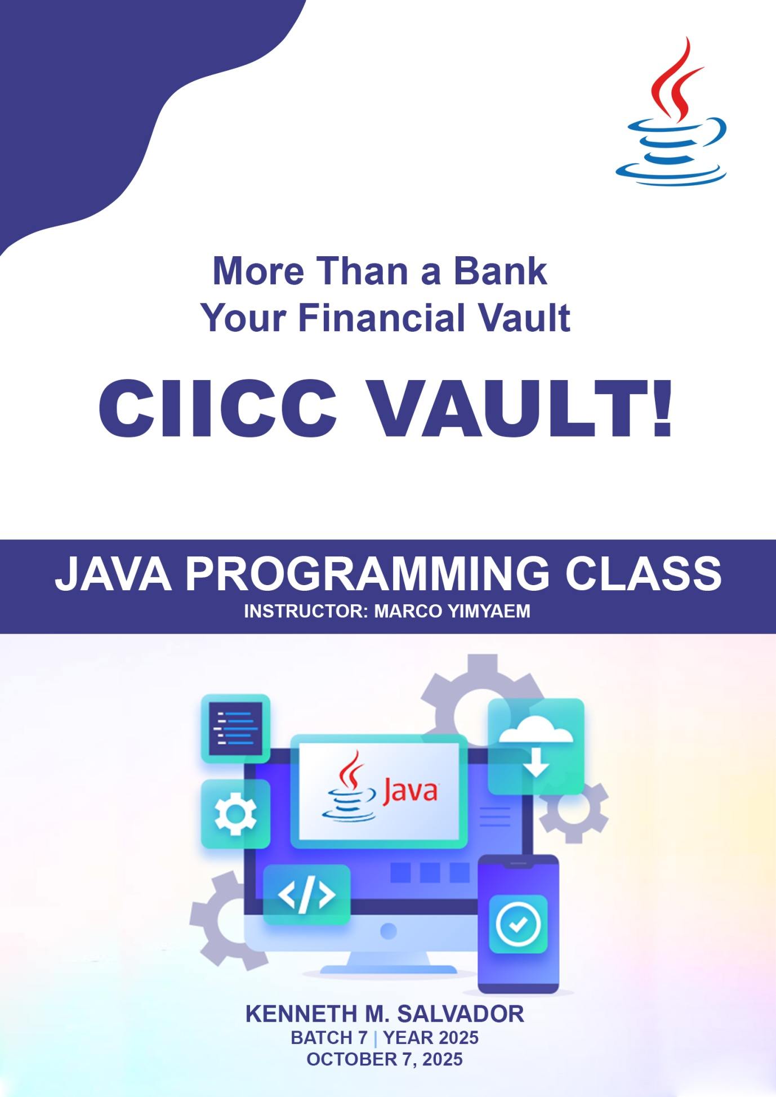

DESCRIPTION:
Ciicc Vault is a school project I developed to simulate the core features of a modern digital banking system. The website is designed to provide users with a secure and user-friendly platform for managing their finances online.

TECHNOLOGY USED:
- IntelliJ IDEA Community Edition - for writing and managing Java code
- XAMPP – to run MySQL locally
- phpMyAdmin – to view and manage database easily through a web interface
- HTML, CSS & Javascript – for Graphic-User-Interface
- Bootstrap - framework to enhance the design of the web
- Fetch API – to communicate between web and java
- Bouncy Castle & Salt Hash - to encrypt and secure the password
- Spring Web MVC - for creating server-side HTML applications and REST APIs, following the Model-View-Controller design pattern.

OVERVIEW
The CIICC Vault Web App is divided into several main components that designed to provide users with a secure and user-friendly platform for managing their finances online.
- Home Page - serving as the first page a visitor sees upon entering the website application
- Login Page – serves as the entry point for users to securely access their personal account or dashboard.
- Registration Page – allows new users to create an account by providing essential information to access the web app.
- Dashboard Page – is the central hub where users can view and interact with key information and Send Money within the web app.
- Transaction History Page - provides users with a detailed and organized view of all their past financial transactions within the web app. This page allows users to track, review, and manage their financial interactions with ease.
- Master Account Page – serves as the administrative or central control hub for managing and overseeing the overall account structure within the web app. This page provides users, typically admins or account owners, with comprehensive tools to manage sub-accounts and account settings at a higher level.

Home Page 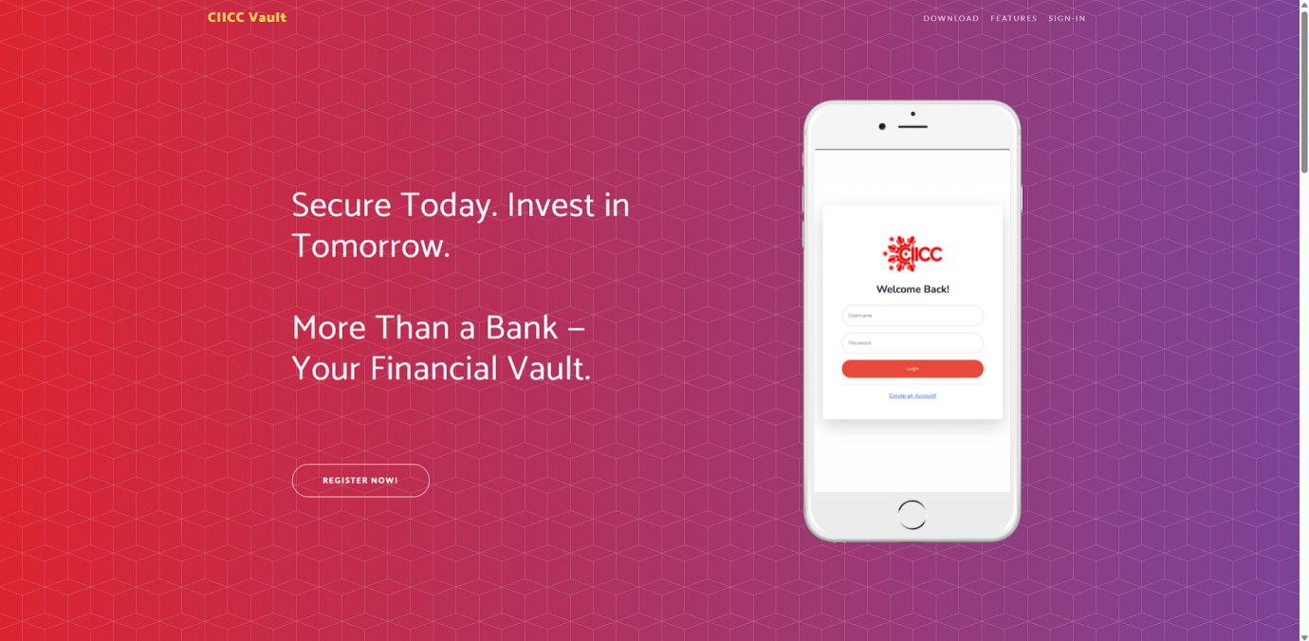

Login 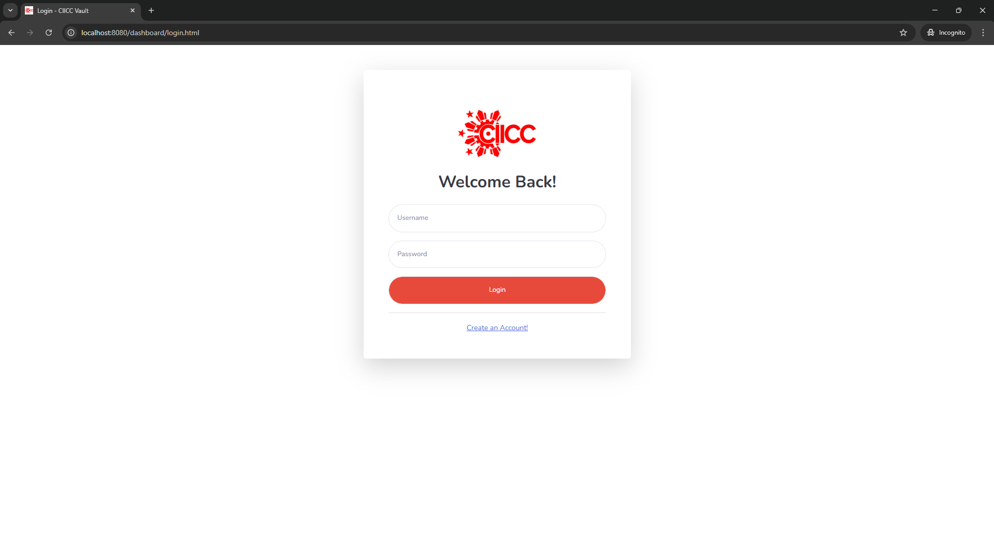

Registration 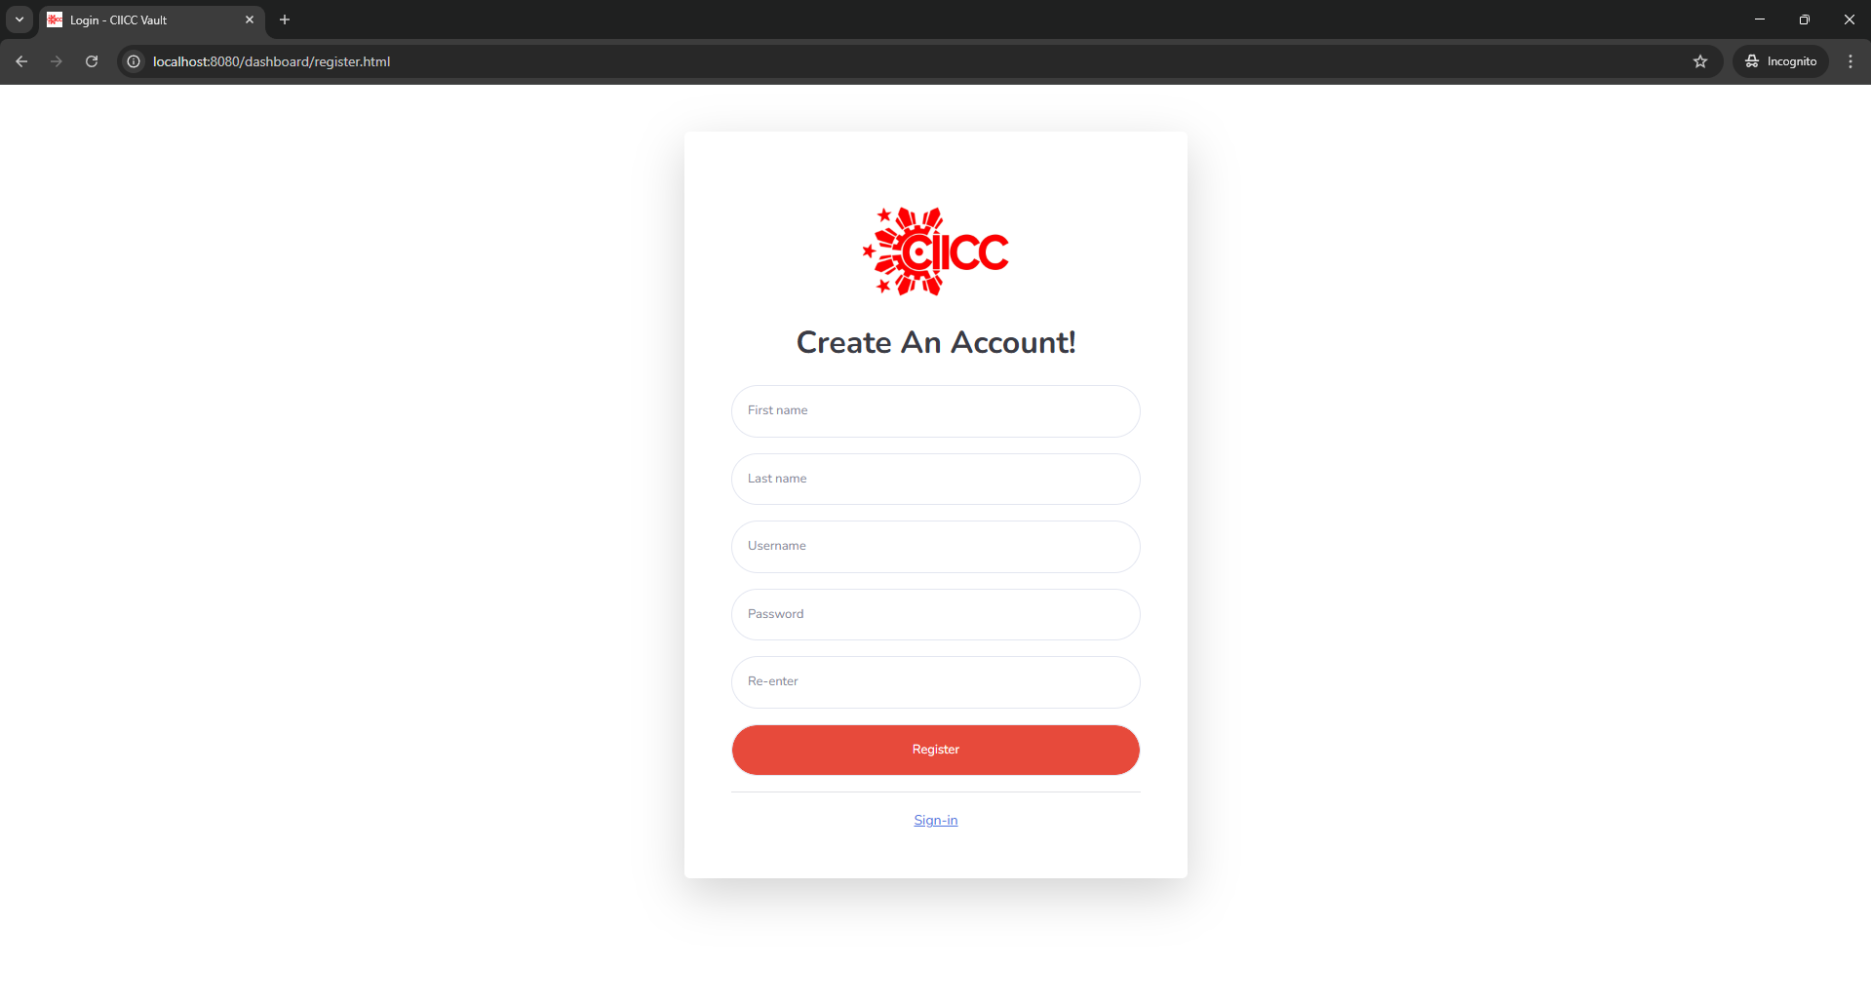

Dashboard 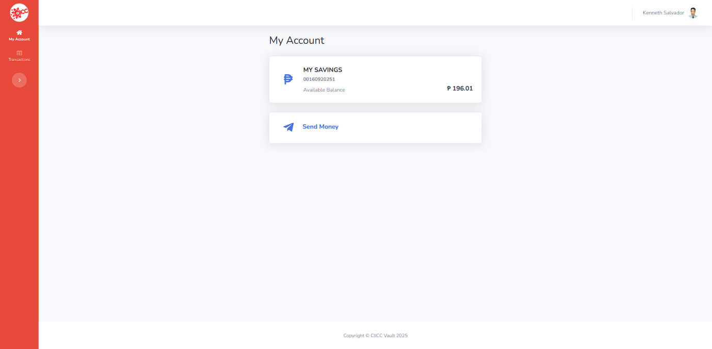

Transaction History
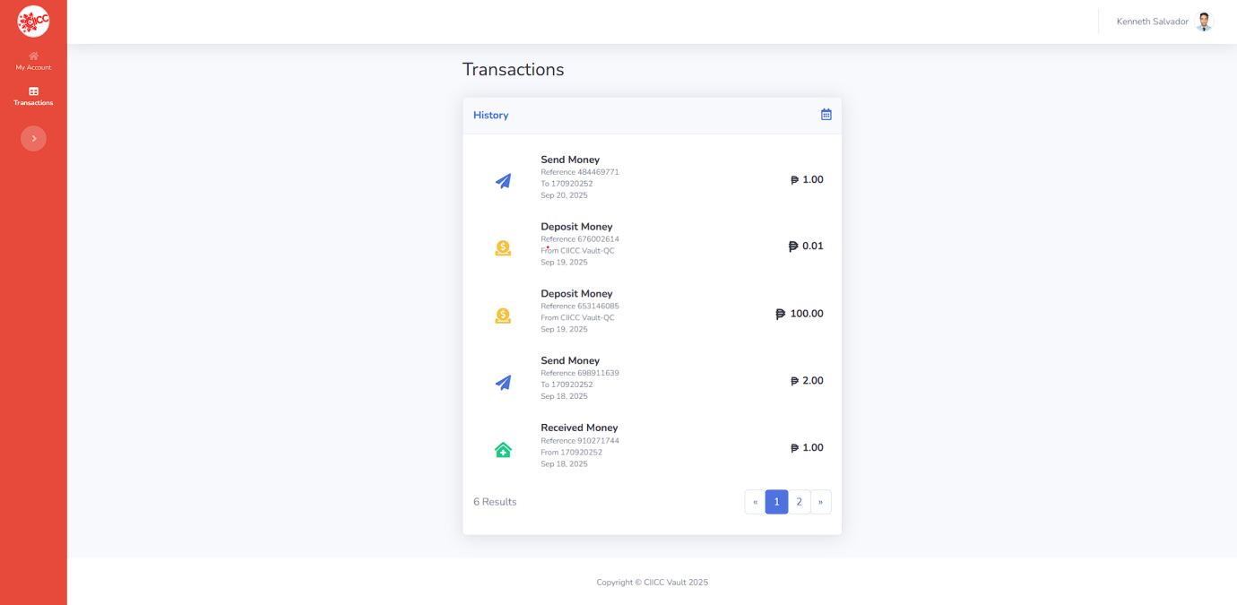

Profile 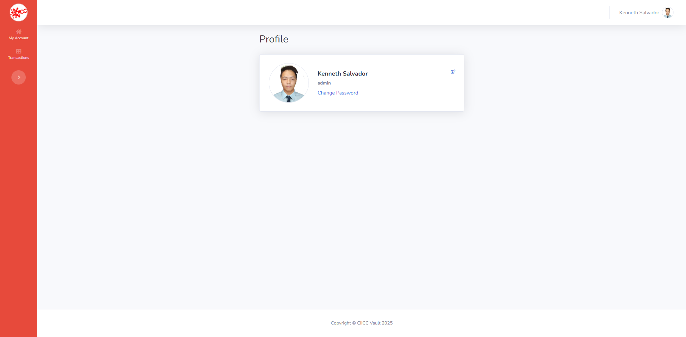

Master Account 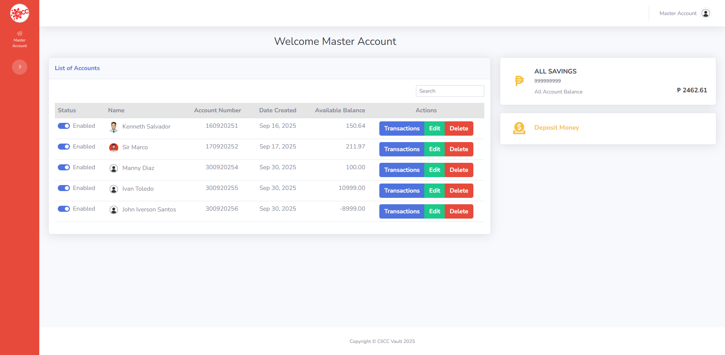

Snap code of Bouncy Castle with Salt Hash
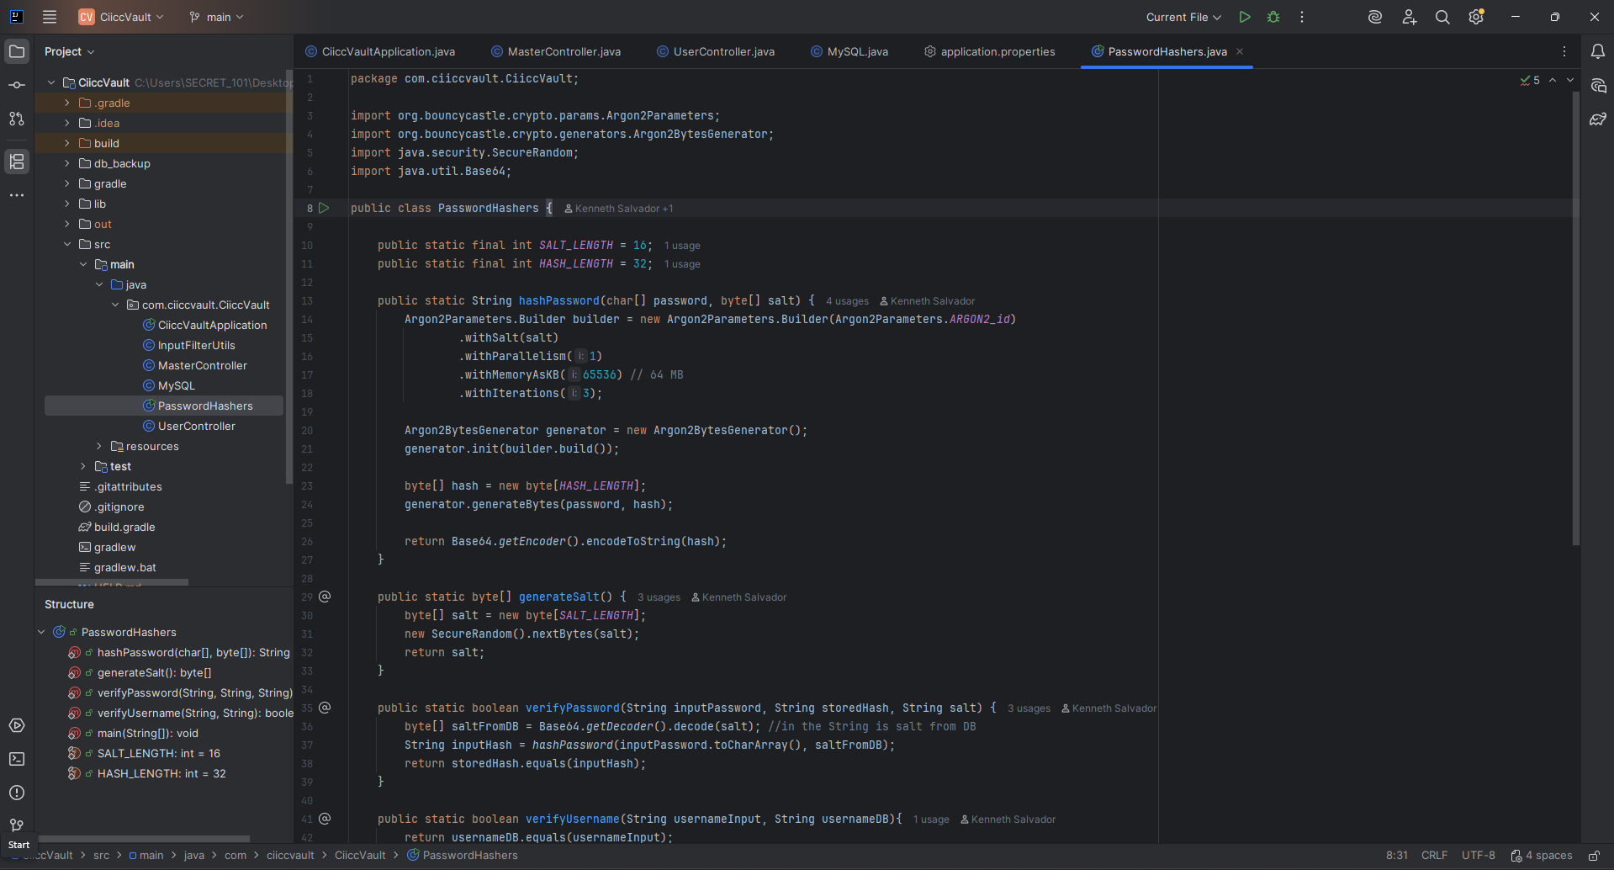

Snap code of my own made SQL Builder
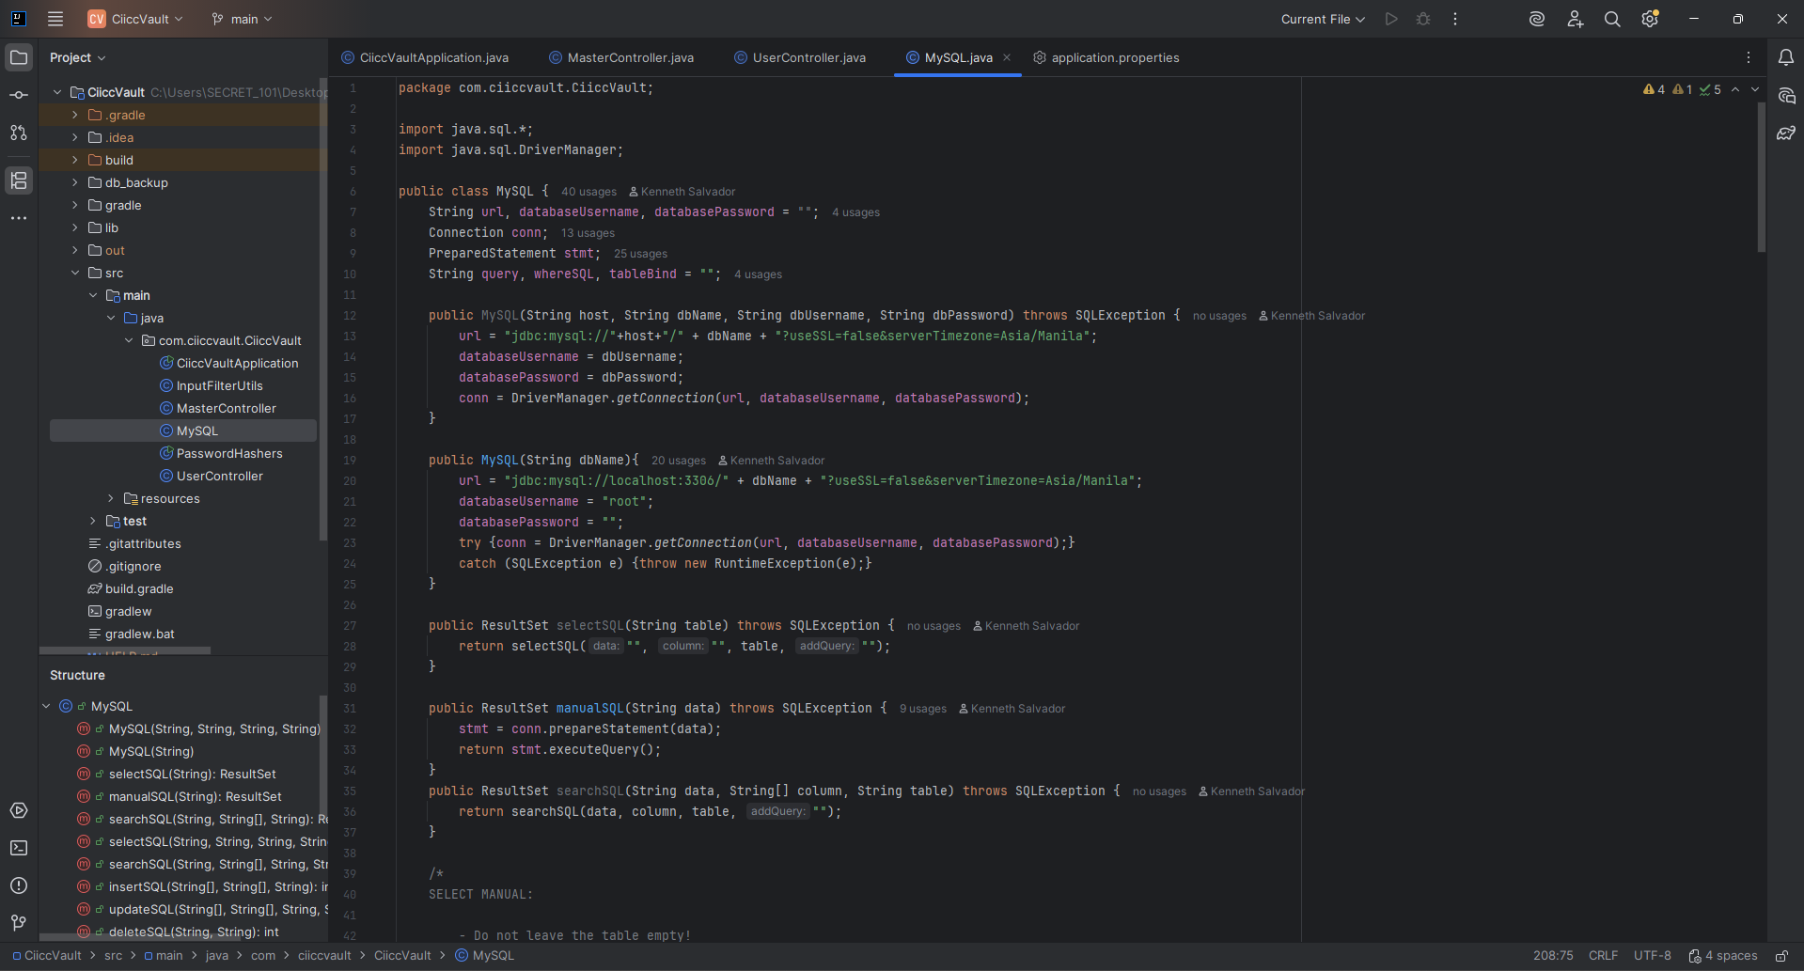

Snap code of User-Controller with Function of Login
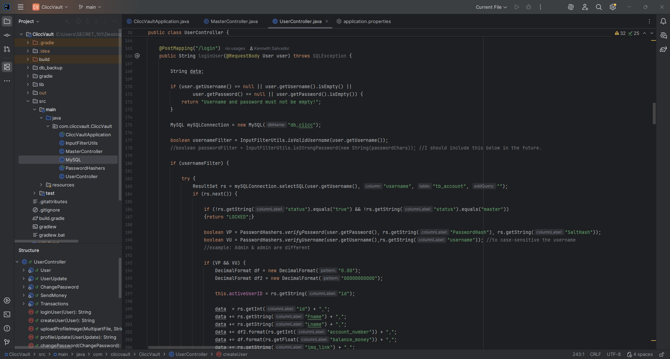


Source code uploaded in Github:
https://github.com/shiene1995/CiiccVault

Contact me.
I’m always open to collaborating on innovative and impactful projects. If you have an idea in mind or simply want to connect, I’d be glad to hear from you. Feel free to reach out anytime.

https://www.linkedin.com/in/kenneth-salvador-9a920216b/

https://web.facebook.com/shiene1995

